Jadestone Energy - Financial Analysis
Financial Analysis | Jadestone Energy | Latest Period: FY 2025 + Q1/Q2 2026 updates | EPIC: JSE

Introduction
Jadestone Energy (AIM:JSE) is an independent upstream oil and gas producer focused on acquiring, developing and life-extending mid-to-late-stage producing assets in the Asia-Pacific region, with operating positions in Australia (Stag, Montara), Malaysia (PM323, PM329), Indonesia (Akatara) and Vietnam (Nam Du/U Minh). The share is trading at approximately 30.5p (up 4.27% intraday to 20 July 2026), off a 12-month high near 34p in June and up sharply from the 16p low set in September 2025. FY 2025 was a year of two halves: strong operational delivery and record production, offset by a large non-cash impairment that flipped the headline P&L to a statutory loss. This report combines the 2025 audited numbers, Q1/Q2 2026 trading updates and the 12-month price chart to arrive at a fundamental and technical view and a rated recommendation.

Full Year Forecast Table
Note: Jadestone reports on a full-year basis with an interim update in September; H1 2026 formal results are not yet published (expected September 2026). H1 (Actual) and H2 (Forecast) columns are therefore marked N/A and the analysis is anchored on the full-year 2026 consensus figures. All figures in US dollars unless stated.
Metric | H1 (Actual) | H2 (Forecast) | ShareScope Est. (2026) | Analyst Forecast (2026) | Your Forecast (2026) | Variance (%)
Turnover (US$m) | N/A | N/A | 424.8 | 424.8 | 415.0 | -2.3%
PBT (US$m) | N/A | N/A | 4.0 | 4.0 | -8.0 | -300.0%
PBT (%) | N/A | N/A | 0.9% | 0.9% | -1.9% | N/A
EPS (US cents) | N/A | N/A | 3.33 | 3.33 | 1.20 | -64.0%
Dividend (US cents) | N/A | N/A | 0.00 | 0.00 | 0.00 | 0.0%
Dividend (%) | N/A | N/A | 0.00% | 0.00% | 0.00% | 0.0%
Operating Cash Flow (US$m) | N/A | N/A | 130.7 | 130.7 | 118.0 | -9.7%
Free Cash Flow (US$m) | N/A | N/A | 59.9 | 59.9 | 45.0 | -24.9%
Net Debt (US$m) | N/A | N/A | 61.8 | 61.8 | 82.0 | +32.7%
Ron's adjustment rationale: I have taken consensus down modestly on the top line and moved PBT/EPS into slightly negative territory to reflect (a) the confirmed extended shut-in of the Stag field to Q4 2026 following Cyclone Narelle damage to the CALM buoy, (b) higher interest costs on the new 12% Nordic bond versus the retired RBL facility, and (c) the likelihood of further modest asset carrying-value pressure if realised Brent averages below US$70/bbl. I keep FCF positive but haircut versus consensus to reflect the Stag revenue gap and slightly higher net debt at year end than the ShareScope forecast anticipates. Insurance proceeds could push the numbers back toward consensus.

Detailed Analysis

P&L Analysis
- Turnover: 2025 revenue landed at US$408.1m against US$395.0m in 2024, driven by record group production of 19,829 boe/d (up 6% year-on-year), with the Akatara gas project (Indonesia) delivering its first full year of contribution. ShareScope forecasts turnover of US$424.8m for 2026 (+4.1%), US$451.7m for 2027 (+6.3%) and US$517.8m for 2028 (+14.6%), reflecting the ramp of Vietnam's Nam Du/U Minh development post FDP approval.
- Cost base and margins: Gross profit rebounded to US$75.9m in 2025 from US$10.6m in 2024, with the underlying gross margin improving to 18.6%. Adjusted unit operating costs fell 21% to US$28.02/boe, aided by the lower-cost Akatara mix. This is the single most important operational data point in the accounts: unit-cost discipline is holding even as Brent softened.
- Operating profit: Adjusted EBITDAX of US$153.0m (management-adjusted) was a 20% increase versus 2024. Reported EBITDA was US$92.9m (statutory) or US$103.3m normalised. Reported EBIT was a loss of US$108.9m, entirely accounted for by a US$126.0m pre-tax non-cash impairment on the Montara and Stag assets, forced by the independent reserves auditor's more bearish long-run oil price deck.
- PBT and net profit: Statutory loss before tax of US$133.7m; net loss after tax of US$110.7m. Strip out the US$126.0m impairment (US$88.2m post-tax) and the underlying business would have delivered a modest positive PBT of roughly US$(7.7)m and a broadly break-even normalised post-tax result of US$(14.7)m. In other words, this is a headline number to look through, not to take at face value.
- EPS: Reported basic EPS of -20.0p (or -US$0.20) for 2025 on 541.1m average diluted shares. ShareScope's 2026 EPS forecast is +3.33 US cents, rising to +6.47 US cents in 2027 and +15.9 US cents in 2028. Ron's more cautious 2026 EPS of +1.20 US cents still puts the shares on a very low forward multiple even before the 2027-28 step-up.

Balance Sheet Analysis
- Net debt/cash: Year-end 2025 net debt of US$89.1m (gross borrowings US$150m less cash US$60.9m). The March 2026 US$200m Nordic bond issue (12% coupon, matures 2031) was heavily oversubscribed and used to retire the restrictive RBL facility, removing near-term amortisation triggers and freeing cash for growth capex. By 30 April 2026 the cash balance had rebounded to US$117.4m including restricted cash.
- Share count: 542.16m ordinary shares in issue at end-2025, average diluted 541.1m for the EPS calc. Very limited historic dilution; no ongoing share issuance flagged.
- Pension: Immaterial to the balance sheet.
- Other: Total equity slipped to negative US$78.9m at end-2025 as a direct consequence of the US$126m impairment. This is an accounting outcome, not an economic one: the same independent reserve auditor values 2P NPV10 at approximately US$519m. Net-of-debt asset value therefore comfortably exceeds current market capitalisation (approximately GBP 165m at 30.5p on 542m shares).
- Working capital: Trade debtors ran high at year-end (US$97.4m for combined trade debtors line) reflecting timing of Malaysian receipts; expect this to normalise through H1 2026 and support the cash conversion story.

Cash Flow Analysis
- Operating cash flow: 2025 operating cash flow was US$83.0m (pre working-capital moves the number is materially higher at approximately US$123.6m, up 75% year-on-year). Net cash from operations was US$91.4m. This is the number that matters for a producer at this stage of the cycle: cash generation is materially detached from the accounting loss.
- Capex: US$83.0m in 2025, directed largely at the Skua-11ST development well at Montara. Forecast US$70.8m in 2026 (down 15%) as Stag capex is deferred and Vietnam moves to farm-out phase before final investment decisions.
- Free cash flow: Consensus FCF of US$59.9m for 2026, US$116.3m for 2027 and US$103.0m for 2028. Management's own indicative unlevered FCF guide for 2025-27 is US$200-240m assuming Brent averages US$70/bbl.
- Cash balances: Opened 2025 at US$95.2m, closed at US$60.9m (net working-capital drag plus capex). Post the March bond issue, cash was US$117.4m at end-April 2026 - a strong liquidity runway.

Management Commentary and Audit Notes
- Positive catalysts already in Q1/Q2 2026: Vietnam Nam Du/U Minh Field Development Plan approval and Gas Sales Agreement in-hand, unlocking approximately 32 MMboe of 2P reserves and triggering a farm-out process to bring in a partner for the development capex. Malaysia PM323 infill drilling programme is exceeding expectations, with the first two wells adding around 6,000 bopd combined.
- Material risk in Q1 2026: Cyclone Narelle severely damaged the Stag CALM buoy in March 2026. The field is shut-in with production not expected to resume until Q4 2026. Physical damage and business interruption insurance is in place, but there is timing risk on proceeds and residual capex risk on repair.
- Going concern: Directors have modelled base and downside cases including the Stag shut-in and are satisfied on liquidity and covenant compliance for at least 12 months. The Nordic bond refinancing removes the near-term liquidity worry that was flagged in the 2024 audit.
- Governance / audit notes: No emphasis-of-matter qualification. The impairment charge is auditor-signed and the negative equity is disclosed. No going-concern warning.

Technical Analysis
Read directly from the ShareScope 12-month daily chart to 20 July 2026 (price in pence).
- Price action and trend: The chart tells a classic recovery story. Late July to early October 2025 was a downtrend from around 21p to a low near 16p. From October 2025 through January 2026, a base built between roughly 18p and 21p on falling volume. February 2026 saw the first meaningful breakout attempt to circa 24p, followed by a shakeout back to 22p. The decisive breakout came in early March 2026 on a large volume bar, taking price from around 22p to 28p in a matter of days, and price then stair-stepped to a new 12-month high of approximately 34p in early June 2026. Since June, the shares have consolidated in a 27p to 32p range and are now closing at 30.5p, up 4.27% intraday. The medium-term trend is up.

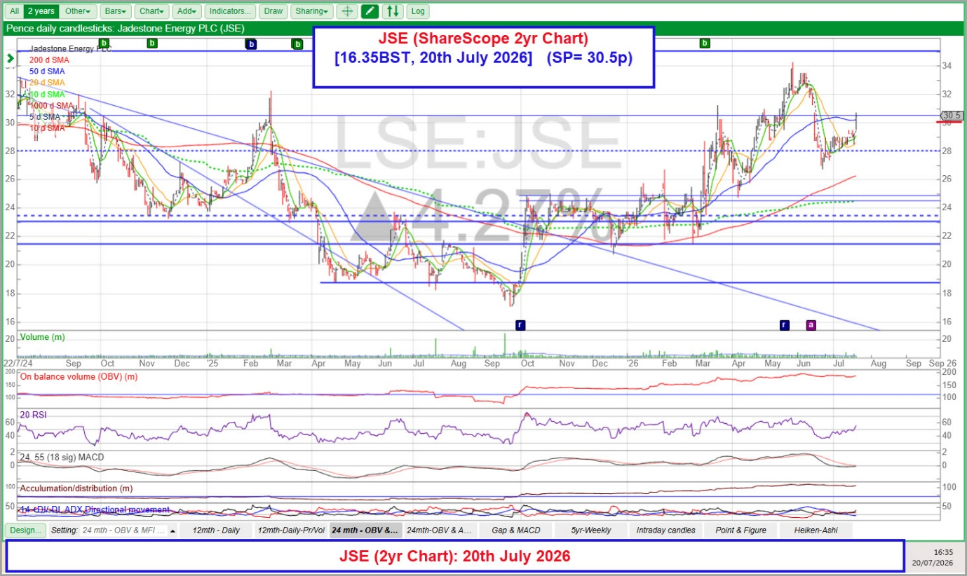
ShareScope 2yr Chart (20th July 2026)

- Support and resistance: The most important horizontal levels visible on the chart are (i) 28p, which has flipped from resistance to support and was tested and held in late June/early July, (ii) 24-25p, a dashed reference level marking the shoulder of the February breakout base, (iii) 21-22p as the December 2025/January 2026 basing shelf, and (iv) 18p as the October 2025 base. Upside resistance is 32p (recent range top) and then the 34p June high.
- Moving averages: Price is above the 5, 10, 20 and 50-day SMAs (the 50-day is climbing at approximately 29p and is providing dynamic support). The 200-day SMA has turned up and is approaching 26p from below, confirming the medium-term change of trend. The 1000-day SMA is now well below price (circa 18-20p and descending), consistent with a multi-year downtrend that has clearly broken. No death cross is in view; the recent posture is bullish alignment.
- Volume: Baseline volume is modest with clear expansion at the two decisive breakout points (March 2026 and the early-June push to 34p). Today's up-day is on above-average volume, which is corroborative of the move back above 30p.
- On Balance Volume (OBV): OBV has trended higher throughout 2026 and is close to its 12-month high, confirming accumulation and not showing a negative divergence versus the June price peak in any meaningful way.
- RSI (20): The RSI is mid-range, around 55, having come off overbought readings seen in early June. There is room to run before overbought is a concern; there is no bearish divergence.
- MACD (24, 55, 18 sig): MACD rolled over from a peak in April/May and is now flattening near the zero line, with the signal line converging. A cross back above the signal line on the current up-move would be technically constructive.
- Accumulation/Distribution: Slight upward drift over 12 months, no divergence versus price, mildly supportive.
- Directional Movement (14, +DI/-DI/ADX): ADX is modest, in the mid-to-low twenties, indicating a trend that is present but not overheated. +DI is fractionally above -DI, consistent with the bullish read from the moving-average stack.
- Overall technical read: The chart is constructive. The March 2026 breakout has been confirmed by a higher high in June and a higher low in July, price is above a rising 50 and 200-day SMA, OBV is confirming, and the pullback of the last month has resolved to the upside on volume today. The key line in the sand for the bull case is 28p; a break of that would open a retest of 24-25p. Above 32p, the 34p June high comes back into play.

Overall Summary and Recommendation
Recommendation: DYOR (Researcher Ron’s view: deep value / special situation).
The 2025 headline loss is misleading. Stripped of the non-cash impairment forced by the reserves auditor's oil-price deck, Jadestone delivered its best operational year on record: production up 6% to 19,829 boe/d, unit operating costs down 21% to US$28.02/boe, adjusted EBITDAX up 20% to US$153m and operating cash flow up 75% to US$123.6m pre working capital. The March 2026 US$200m Nordic bond refinancing has removed the near-term balance-sheet worry, and the Vietnam FDP approval brings approximately 32 MMboe of 2P reserves onto the growth ledger with a farm-out available to fund the capex.
The immediate operational drag is the Stag shut-in to Q4 2026 following cyclone damage, but insurance is in place, and the outperformance of the Malaysian PM323 infill wells is a meaningful offset. With an independent 2P NPV10 of US$519m against a current market capitalisation of approximately US$220m (GBP 165m at 30.5p) and net debt of under US$90m, the shares trade at a very heavy discount to underlying asset value.
The technical picture supports the fundamental case: a base built between 16p and 21p through late 2025, a clean March 2026 breakout on volume, a higher high at 34p in June, and now a higher low being posted in July with price recovering above 30p on above-average volume. The trend is up, OBV is confirming, and the risk/reward from here is asymmetric: a break of 28p is the stop; the June 34p high is the near-term upside pivot with the fundamental case pointing to materially more over 12-24 months as 2027-28 EPS steps up.
This is a deep-value, special-situation call. It is not a low-volatility income name; the dividend is zero, the 2025 headline is ugly, and there is real single-project (Stag) event risk. Position size accordingly - but the balance of fundamentals, valuation, catalysts and the technical set-up rates a BUY.

Risk Warning: Investing involves significant risks, including potential loss of entire investment. Values fluctuate and past performance does not guarantee future results. This analysis is not financial advice. Assess your financial situation, risk tolerance, and investment objectives carefully. Conduct your own research (DYOR) and consult an independent financial advisor before making decisions.
DYOR: Ron, [Mick's AI Research Analyst (20th July 2026)]
[Formatted: Mick (21st July 2026)]

